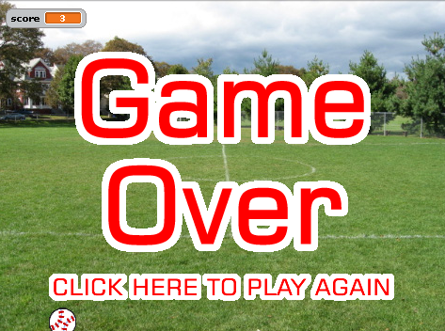 | Catch the Ball  A ball falls from the sky.  When you click on it, it glides to a random position at the top of the screen and begins to fall again, but a little faster. If you catch it 6 times, you win. If the egg touches the floor, you loose.
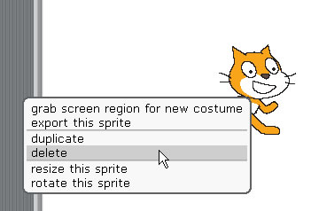 | RIGHT mouse click on the cat and select 'delete'
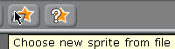 | Click ‘Choose new sprite from file’
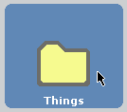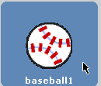 | Click on ‘costumes’  Double click ‘Things’  Click ‘baseball1’  Click ‘ok’
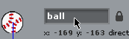 | Rename the sprite to ‘ball’.
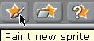 | Click ‘Paint new sprite’
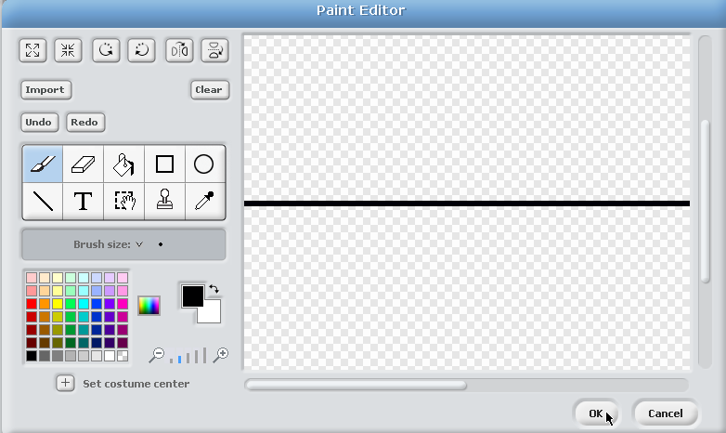 | Draw a long black line (this will be the floor).  Click ‘ok’.
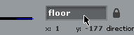 | Rename the sprite to ‘floor’. Position it at the bottom of the screen.
You also need to import TWO sprites from the shared area (or copy them to your home area first). They are:
Game Over.png
You Win.png

Name these sprites:
gameover
win
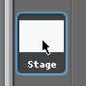 | Click on ‘stage’
 | Click the ‘backgrounds tab’,  Click on ‘Import’
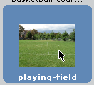 | Locate a suitable background.  Click ‘ok’.
 | Click ‘Variables’
 | Click ‘Make a variable’
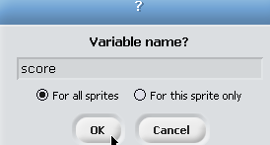 | Type in ‘score’.  Click ‘ok’.
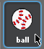 | Click the ‘ball’ sprite.
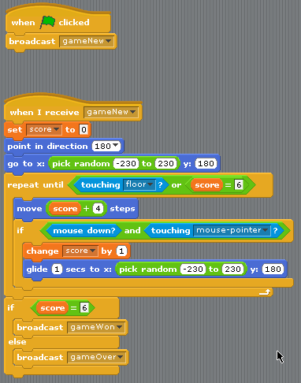 | Add the blocks as shown.  To create a broadcast, select the ‘new’ option at the bottom of the dropdown list on the block itself.
 | Click the ‘Game Over’ sprite.
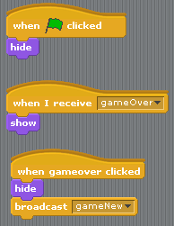 | Add the code as shown.
 | Click the ‘win’ sprite.
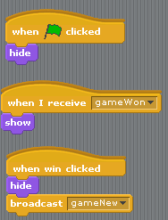 | Add the code as shown.

You should now have a complete game.

Use a word processor to explain why broadcasting events can be a good idea.

